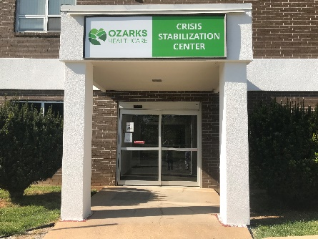

Behavioral Health

Crisis Stabilization Center
Nurturing Hope, Improving Health, and Encouraging Wellness- every person, every time
ABOUT OZH BEHAVIORAL HEALTH CENTER
OZH BHC is the administrative agent for Department of Mental Health (DMH) Service Area 18, a seven-county region of south-central Missouri.
OZH BHC provides the following services:
      - Psychiatry
      - Counseling
      - Group Therapy
      - Integrated Treatment of Co-Occurring Disorders (ITCD)
      - Crisis Services (ACI)
      - Emergency Room Enhancement Program (ERE)
      - Community Behavioral Health Liaisons (CBHL)
      - PSR Day Treatment
      - Case Management
      - Healthcare Home
      - Residential Support Program
OZH BHC CRISIS STABILIZATION CENTER
OZH CSC is a DMH funded, medically monitored program that provides an alternative to psychiatric hospitalization.

PROGRAM GOALS
      - Increase access to Trauma Informed Urgent Psychiatric Services
      - Development of Integrated Health Services
      - Reduce burden on local ERs and Law Enforcement for Behavioral Health Services after hours and weekends
      - Increase the availability of psychiatric beds
PROGRAM SERVICES
OZH CSC provides services such as:
  - Psychosocial Assessment
  - Psychiatric Evaluation & Medical Services
  - Crisis Intervention & Brief Therapy
  - Case Management & Referral Services including:
      - Medicaid Applications
      - Community Resources
      - Employment Application Assistance
      - Housing Application Assistance
      - Transportation Assistance
      - Referrals for Physical and Mental Health
    - Peer Support
WHO WOULD BENEFIT?
    - Anyone in a mental health crisis who requires stabilization either through brief therapy techniques, medication management, or both
    - Adults who have case management needs, including assistance to accessing sheltered housing
    - Adults who are currently abusing substances and require urgent assistance in accessing inpatient substance abuse facilities
ELIGIBILITY REQUIREMENTS
    - VOLUNTARY and willing to actively participate in admission process
    - Not actively suicidal, displaying aggressive behaviors or making threats of harm against others
    - Medically stable, free of communicable conditions and ambulatory
    - The OZH CSC is NOT a placement for emergency housing

CONTACT US!

ADDRESS
1100 Kentucky Ave.
West Plains, MO 65775
*Turn off of Hwy 63 toward the round-about.
Take the 1st exit and turn onto 6th street. The Crisis Center will be on your LEFT*

24 HOUR CRISIS HOTLINE
988

HOURS OF OPERATION
7 Days a Week
11AM-9PM

PHONE
Direct: 417-505-7878
Main Hospital: 417-256-9111
BHC Outpatient Clinic: 417-257-6762

FAX
417-553-4989

STAFF
CSC Clinical Manager
Christy Jackson, LPC
417-257-6762 ext. 1640
Cell: 417-372-5885

